Adults’ Events Stewards’ Trust Risk Assessment Form
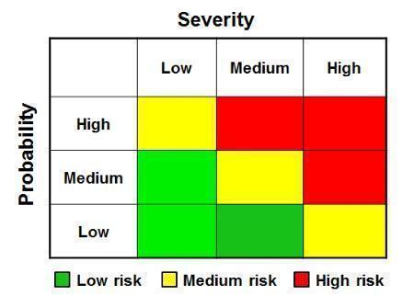
Event:
Date of event:
Location of event:
Assessment completed by:
Date:
General comments:
Signed off by:

Additional Notes & Actions relating to the event:
[Include any other observations, special needs, or specific considerations relevant to the venue]

Potential Hazard | Persons Exposed | Risk Rating  (Prob/Severity) | Existing Control Measures | Additional Control Measures | Who to implement
Safeguarding | Vulnerable Adults | Low /High  Medium | Stewards’ Trust have an established Safeguarding Policy for children and vulnerable adults. It is based on guidance from thirtyone:eight. Fully reviewed and updated Jun 2024. A public version is accessible via our website.  Our events are not tailored for vulnerable adults. Should someone with known care/support needs be accepted on to the event our policy states they will need to bring a carer.  The policy is provided to event leaders.  Each event will have a Designated Safeguarding Host (DSH)(often the Chief Host), who is the first point of contact and who will liaise with ST Designated Safeguarding Officer (DSO) (Helen Paterson) who can support Hosts with any concerns. | Hosts to familiarise themselves with procedure to follow should someone disclose a concern or harm | Host team and Designated Safeguarding Host
Fire and Evacuation | All | Low / High  Medium | All venues we use comply with legal responsibilities and have up to date fire safety policy and protocol | Hosts to confirm venue has Fire alarms, extinguishers, clear exits, and ensure communication of evacuation plan | Chief Hosts
Medical emergencies (e.g. falls, heart conditions) | Attendees with pre-existing conditions | Low/High  Medium | All attendees will have provided medical information before the event | Ensure guests know how to access local medical services if required
Activities (eg.. walks) | All taking part | Low/Medium  Low | Adults engage in activities by independent choice | [Ensure walks are supervised by appropriate person]
Slip, trip, fall - general (e.g. loose cables, wet floors) | All | Low/Medium  Low | Venue has responsibility to prevent harm by removing hazards or using Hazard signs | Hosts to be vigilant  Any obvious hazards to be pointed out | Venue Staff  Chief Hosts
Access and Mobility Issues (eg uneven flooring) | Elderly, disabled attendees | Low /High  Medium | Guests asked for Medical information and extra information at registration so accessibility provision can be discussed before arrival  Venues clear about what is possible in advance | Hosts to be vigilant  Any obvious hazards to be pointed out | Venue Staff  Chief Hosts

